**STORY**

The stories are written by the product owner and Stakeholders (a Stakeholder is any person that has an interest in the product, it could be monetary interest or a person who will be using the product). JBehave consists of two parts, the first part is called the narrative and the second part is the Scenarios which are written using Gherkin. Both of them are written in business language, allowing them to have common language in order to have a better communication and reduce the misinterpretation. 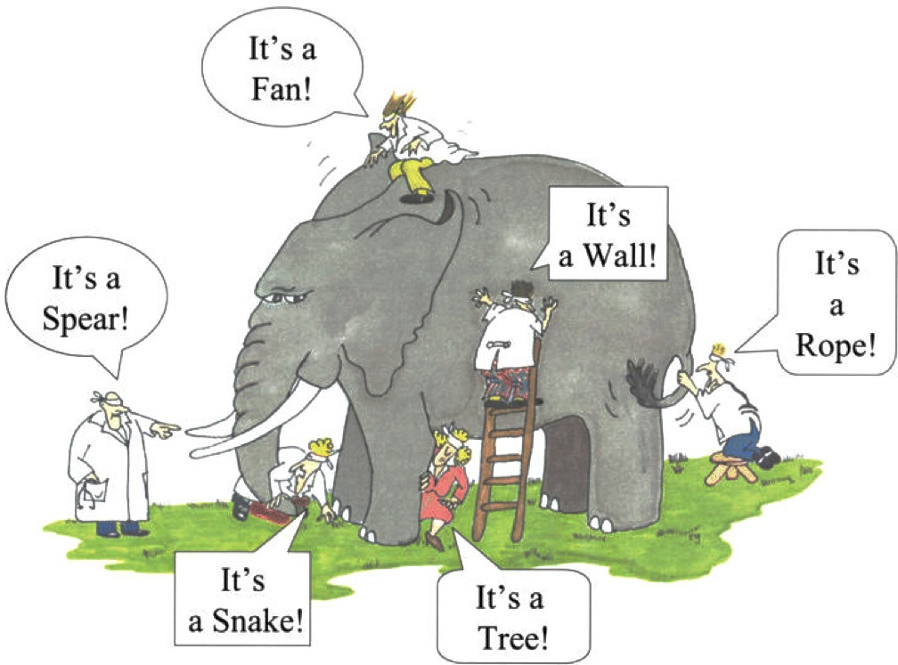

*Image 1: Illustrates how each person interprets with what they are in contact due that they are blind folder and they aren’t able to see and not willing to move around to see the big picture. This same thing happens when the development team and the stake holder analyze a problem, they can only associate with what they are in contact with.*

The hardest task of developing a software is for all of the people involved to have the same idea of the feature and be able to write that concept in a story so that the person that reads it will be able to abstract the same idea. Even though the people who are working on the project might speak the same language for example (English, Spanish or any natural language), more than likely there will be communication problems which is usually caused by the different jargons in language caused by the area they work. For example the development team uses a technical jargon to communicate with the stakeholders who generally has a different Jargon which might be a more business oriented to communicate among themselves.

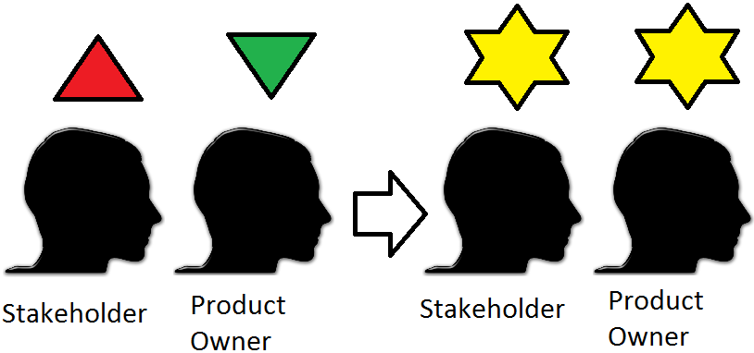

*Image 2: Illustrates the ideal situation of each person having different interpretation of a story and after talking it thoughtfully they both end up with the same concept of the story.*

This issue has been solved with the implementation of Gherkin. Gherkin is a new way to write test cases and it can be written in 60 different natural languages. It uses the following Basic Syntax:

Scenario: Given When Then

Depending on which testing tool you will use, additional tags to the basic ones might be used. For example if you use Cucumber you will need to use the feature tag. In addition to this tag you will have to save your test case with an extension “.feature”, and they are called features.

JBehave uses Gherkin and also follows the basic syntax when you write the test cases. This test cases are called stories and they are saved with an extension “.story”. A story is used to capture the behavior of a module of the software being developed. It is an important tool because it allows the people who interact with the story to have the same concept of the behavior we what to test. The people who will interact with the story are : stakeholder, product owner, QA, Scrum Master, Development team) to define it in a way that reading it you can get the concept of the behavior being test.

A Story written in behave follows the following

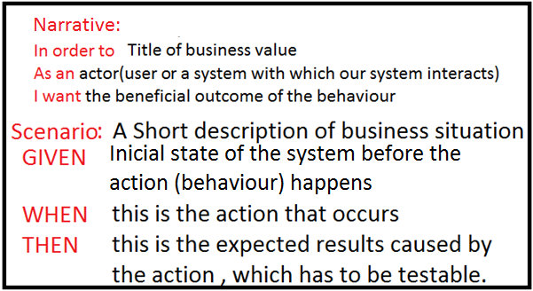

*Image 3: Example of the syntax of a JBehave story, and brief description of what each tag does.*

When your planning on writing a test case you always have to take under consideration the Single Responsibility Principle (this principle states that a piece of code like a function or class can only do one thing and one thing only). SRP allows you to have a very maintainable code since it has high cohesion and low coupling in other words allowing you to only change the code in one place instead of analyzing the entire code and seeing the interdependencies with other modules and having to change in all of the modules where a dependency exists.

When you’re writing a test case using Gherkin and JBehave there are a few keywords used to write any story. These are:

* Scenario: This is the title that you will give to the test case, will provide a person that reads this test case the intention of what this test case test; in other words it will provide in a natural language a title to this business logic module.
* Given:Is a step, of the precondition of the system, it is like a stage. Only in this precondition, the action can happen.
* When: is a step in which the action happens or you can think of it as in this step is where the behavior of the test case happens.
* Then: is a step, in which you can see the post condition of the action generated in the previous step.
* And: is a step in which you can use when you have several tags of Givens or Whens. When you have several tags of the same type you only write the first tag as its’ respective Given or When and the following same tags as the first as an And tag, This allows you to have in a Scenario to have several tags of Givens, Whens, and know where they start. For example: the following Scenario:

Description: You are in the login page and the Log in button is disabled by default. In order for the login button to be enabled first the user must insert the username and the password, after filling them out you must click on the checkbox to verify there is no sql injection in the data inserted or a Denial of Service Attack. After everything is verified it enables the Sign In button.

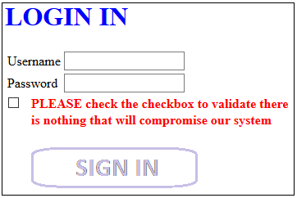 Img

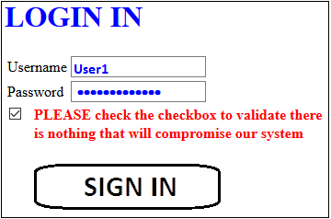

Scenario: User fills in user, name and checks the checkbox for validation. After validation the log in button will be enabled

Given user is on the login homepage

When user fill username field When user fills password field When user checks the checkbox

Then the Log in button will be enabled

Scenario: User fills in user, name and checks the checkbox for validation. After validation the log in button will be enabled

Given user is on the login homepage

When user fill username field And user fills password field And user checks the checkbox

Then the Log in button will be enabled

* But
* Example

**FINDING ELEMENTS IN A WEBSITE**

When you are making User Interface Testing with Behavior Driven Development one webpages, it is important to be able to find any elements on a webpage so that you can be able to work with them in order to be able to comply with the respective story. There are different tools that you can use to reach any element. One of them if @FindBy which allows you to find an element using either xpath or css selector. It is a better practice to try to find and element by using a css selector rather than by its’ xpath.

If you want to identify an element with a css selector using @FindBy you can identify an element by:

* id
* tagName

Another way if identify an elment

**PROJECT ORGANIZATION**

The Project is organized in 3 different paths

 src/test/resources

In this folder you can store all the test cases. Starting in this folder and all of its’ child folders you need to add the Narrative.txt. A narrative is a short description of the intention of what will be tested in the folder. When you write a story, the narrative of the story needs to be the same as the narrative inside the Narrative.txt file. You need to define each scenario in a different folder.

 src/test/java

In this folder you need to add a class for each scenario. In this class you need to define where your story is located and its respective step definition.

 src/main/java

In this folder for each story you will have a new folder with two packages

* steps
* pages

In this packages you will have strong cohesion and low coupling. In the steps package you will have a main class called step definition class you will have a step definition

JBEHAVE AND SERENITY will help you with testing automation, allowing to make acceptance testing as well as regression testing.

SERENITY